Example of BLASTN output and Analysis

In this example we have taken the coding sequence from a Drosophila gene called hunchback (the protein made is involved in early embryonic development).

Following the instructions for the BLASTN search we get the following results (NOTE- the red outline highlights the DNA sequence names and the E values):

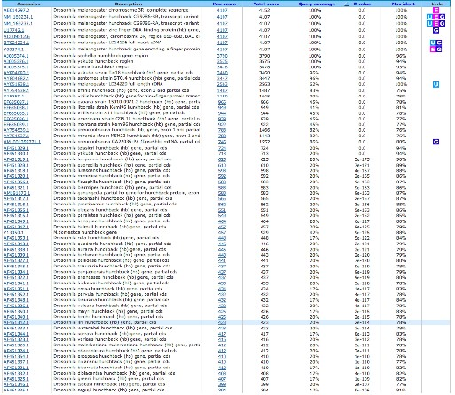

The first hit (look below at a more magnified version) is from the Drosophila melanogaster genome project, but the next two sequences are from RNA transcripts of the gene. Notice that their E values are 0.0, i.e., the likelihood that our sequence aligns with these sequences by chance is zero, indicating that these are real alignments with biological relevance. The fourth hit provides a hint about Hunchback’s function, as the description tells us it is a Zinc-finger DNA binding protein. These proteins generally serve as transcription factors that control the transcription of other genes.

Although we already have an idea of what our gene might encode, we are interested in further probing the function of our gene. If we click on the “Accession” number to the left of the DNA sequence, we can access a site that may discuss the function of the gene. It turns out in this case that if we click on the first three sequences that happen to be from the D. melanogaster genome project, they do not address the function of the gene. However, if we click on the fourth accession number (U17742.1) we can look at the journal references linked to this sequence. The first reference listed gives us some information about the function of the gene. It appears that this gene encodes a protein involved in segmenting the early embryo.

Remember: the function of your gene is NOT to make the phenotype of the mutant! That is what happens when the gene is broken in some way.

Looking further down the list, we find the first non-Drosophila sequence (highlighted in the green section of the original results from the BLASTN search):

This sequence came from M. domestica and has been identified as the hunchback gene for this organism (we’ll check what the authors mean by this in a moment). The E value is 9e-125 or 9 x 10⁻¹²⁵. Clearly, it is highly unlikely that our query sequence aligned with this non-Drosophila sequence by chance as this E value is very, very close to 0.0.

If we click on “Max Score” (in this case 457), we will see the alignment of the M. domestica sequence with our D. melanogaster sequence. Click here to view these results and learn what they mean.

If instead of clicking on “Max Score”, we select the accession number to the left of the DNA sequence description, we get the database entry for the sequence:

Useful information from this entry includes the description of the organism:

SOURCE Musca domestica (house fly)
ORGANISM Musca domestica
Eukaryota; Metazoa; Arthropoda; Hexapoda; Insecta; Pterygota;
Neoptera; Endopterygota; Diptera; Brachycera; Muscomorpha;
Muscoidea; Muscidae; Musca.

So we discover that M. domestica is in fact the common house fly!!

Next we see that there is a publication associated with this DNA sequence:

REFERENCE 1
AUTHORS Bonneton,F., Shaw,P.J., Fazakerley,C., Shi,M. and Dover,G.A.
TITLE Comparison of bicoid-dependent regulation of hunchback between
Musca domestica and Drosophila melanogaster
JOURNAL Mech. Dev. 66 (1-2), 143-156 (1997)
PUBMED 9376318

The title of this primary literature journal article suggests that the authors did experiments to show that the house fly sequence is equivalent to the Drosophila sequence.
We can click on the link (9376318) to see the Abstract from the journal article. The abstract is a concise summary of the information presented in the full journal article. A reader can scan through an abstract and as a result, decide whether the paper is worth reading OR get a quick synopsis of the experiments that were done and the conclusions that were drawn. You will be writing an abstract for your fly paper, so it is a good idea to read through this expertly written one to get a better idea of how yours should be written.

