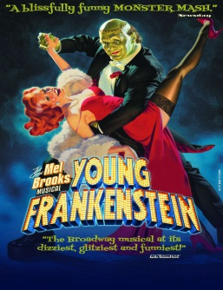

YOUNG FRANKENSTEIN

SM Team Assignments

Laurie Kincman (SM) | Teah Crow (ASM) | Joe Reuss (ASM)
Blocking & Scheduling | Scenery | Costumes
Lighting & Sound Cues | Props | Special Effects
Prompting/Line Notes | Prompting/Line Notes | Prompting/Line Notes
Booth | SL | SR

Teah
- Help to set up the theatre each night for rehearsal.
- Update Props List on a weekly basis- by Tuesday of each rehearsal week
- Know what rehearsal props we have, and what will be needed for each night’s rehearsal
- Check in with the scene shop and prop shop outside of production meetings as needed
- Track all hand props and furniture in rehearsal
- Create preset list
- Work with Joe to create shift plot
- One the cast is off-book, share responsibility for prompting and line notes during rehearsals
- Learn full backstage track for SL

Joe
- Help to set up the theatre each night for rehearsal.
- Check in with the costume shop outside of production meetings as needed
- Schedule fittings & coordinate use of costume pieces in rehearsal
- Update Character/Scene Breakdown as needed
- Create costume plot/quick change plot
- Track all special effects in the show and check in with Ron as needed to understand how they work
- Work with Teah to create shift plot
- Once cast is off-book, share responsibility for prompting and line notes during rehearsals
- Learn full backstage track for SR

