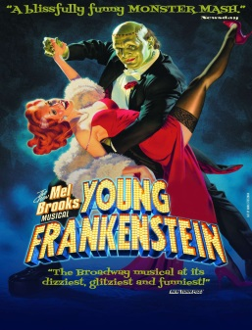
REHEARSAL REPORT
Production: Young Frankenstein
Date: Wednesday February 5
Stage Manager: Laurie Kincman
Assistant Stage Managers: Teah Crow, Joe Reuss
Guests: None
Call Began : 6:30 pm Breaks: 7:55 (10) Ended 9:30 pm
Late: Madrzak (15) , Steidl (exc.) Absent: none

Rehearsal Breakdown
Time | What | Who
6:30-7:05 pm | Act Two Music with Gary | Full Company except O’Hara, Sveen
7:05-9:30 pm | Review Blocking from Top of Act II (with music) and then keep going | Beyer, Boydston, Bush, Cooke, Cornwell, Costello, Fanshaw, Gray, Holloway, Holmes, Johnson, Katschke, Madrzak, Masterson, Mian, Napolski, Novak, O’Hara, Schneider, Steidl, Taylor, Varelis, Ward, Williams, Wilson, Youngren

Next Rehearsal
Thursday February 6
Time | What | Who
6:30-8:30 pm | Choreography: “Family Business” | Beyer, Boydston, Cooke, Gray, Holloway, Madrzak, Masterson, Steidl
8:30-9:30 pm | Choreography-“ Surprise” | Beyer, Boydston, Cornwell, Gray, Katschke, Steidl, Ward, Williams

Scenery/Technical Direction (Mandy and Ron):

11. Could there be a place in the bookcase unit for Frederick to put back the 3 books he is holding at the top of I-7?

12. Is it possible for an actor to get to the upstage side of the castle door unit without being seen?

Props (Mandy)

13. Please ADD (3) suitcases for three female passengers in I-3, in addition to those already on the prop list.

14. Frederick will use the stethoscope in both I-10 and II-2.

15. The stone fell out of Elizabeth’s engagement ring when she tossed it offstage tonight. The ASMs found it and put it in the ring box.

Lights (Nick):

16. Laurie has some additional score cuts in and “Family Business” to give you.

Costumes (Joe)

Please see prop notes #14 and 15

17. Thank you for Igor’s cape and hood—it worked great and he did not have any problems hearing or tripping over it.

FITTINGS
Thursday February 6  1:00 pm- Connor O’Hara  1:45 pm- Katy Williams | Friday February 7  1:00 pm- Mitchell Gray  1:15 pm- Casey Schneider

Sound (Ron):

No notes tonight, thank you.

Miscellaneous:

No other notes tonight, thank you.

Thanks everyone,
Laurie Kincman, SM

