Instruction on how to print slides from PowerPoint Presentation that would save papers. Please follow the following instructions.

- Click File → Print as the normal routines for printing documents. Don’t be lazy and click on the icon.

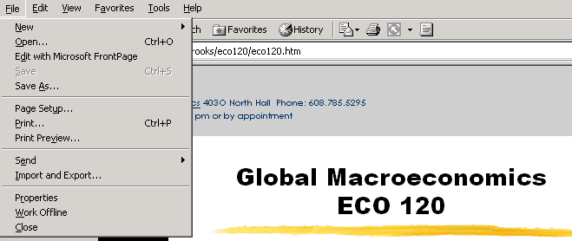

- Double click on the highlighted default printer as shown below.
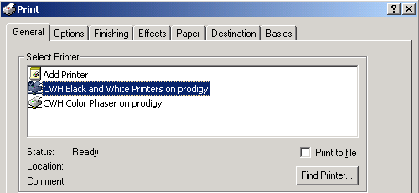

- Once you done step 2, it will take you to this screen. Click on the scroll down box that says Print what:
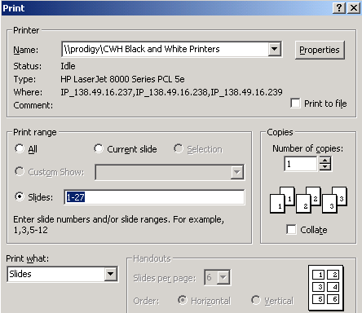

- Select Handout and leave the default Slides per page as 6.
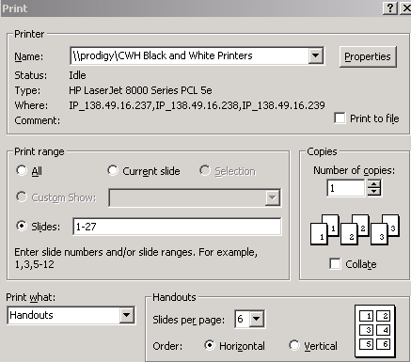

- Click to print!

* By the way, you also have the option to choose which slide you want to print too. Lets say you only need to print from slide 10 to 27. From Print range where the default Slides: 1-27, you can change it to 10-27.

