Qualtrics is web based survey software that is currently being used by UW-La Crosse. Your use of the Qualtrics survey software is authorized **for this class only**. **Any use of the software for personal purposes will result in a failing grade for the course. In addition, do not allow anyone outside of your group to access the software. You must “share” the survey with your instructor in the same way you designate sharing with group members.**

The following is a set of instructions for student groups logging into Qualtrics, creating a survey, then sharing it among the group members. Only **ONE** group member need follow **ALL** these instructions. The rest of the group members need only log in - they should see the survey that has been shared with them.

Qualtrics: Getting Started.

First login with your 8.4 here <https://secure.uwlax.edu/qualtrics/>

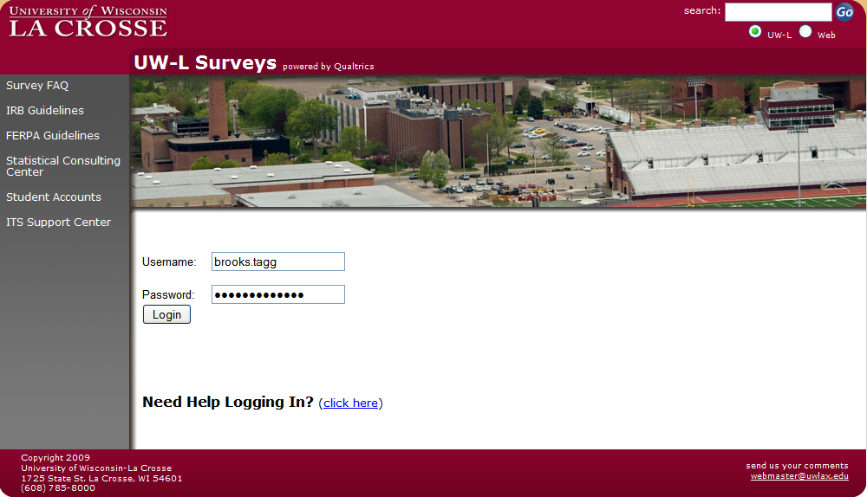

Next click on the Create Survey tab.

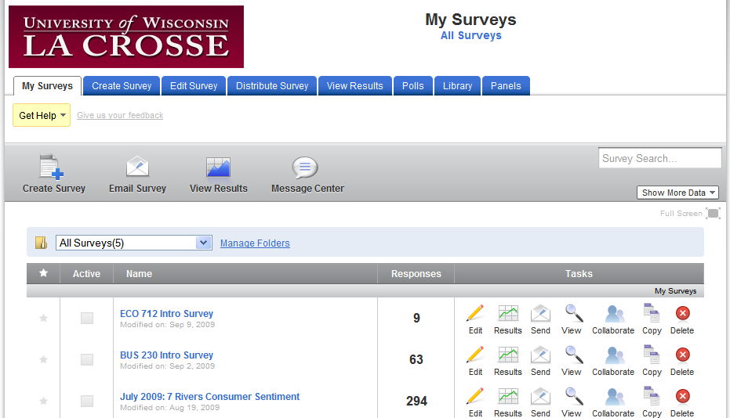

Next click on the Quick Survey Builder.

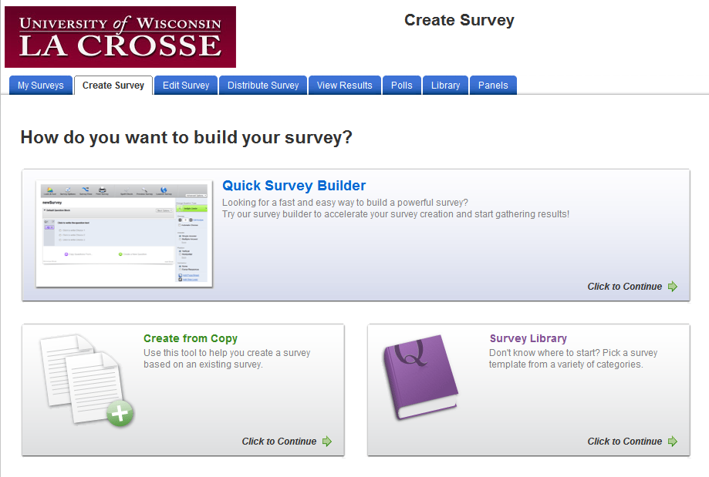

Pick a name for your survey. There should be no need to put it in a folder as you will have one survey. This example calls the survey “temp” but you should use a more appropriate name for yours.

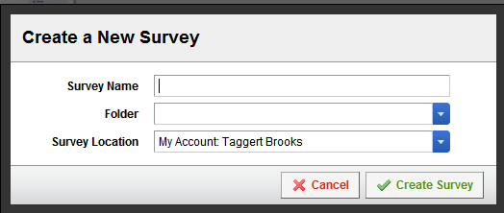

Now that the survey has been created you are in the Edit Survey Tab. Clicking on Create a New Question will bring up the question type options.

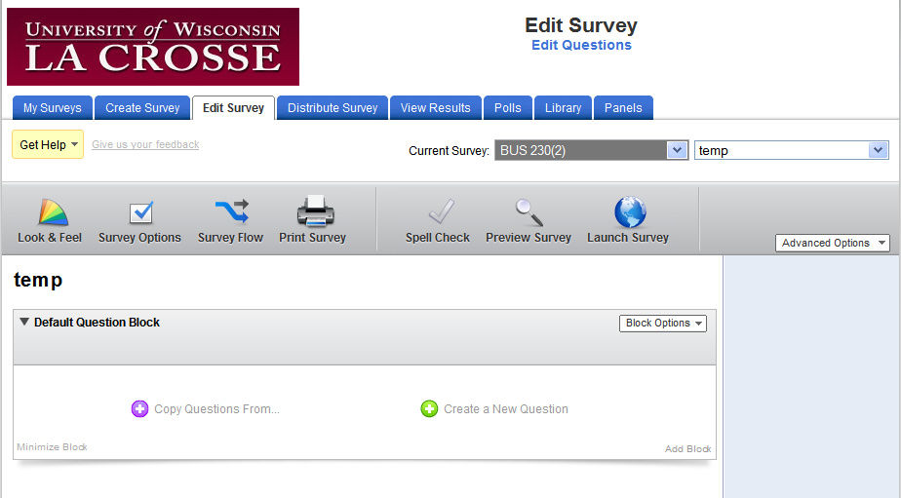

The Qualtrics interface is dynamic. You can change most anything by merely clicking on it. Clicking on the bold question text allows you to type in your question. You can then use the automatic response categories or write your own. Don’t assume the automatic response categories are better than yours – use what you have decided to be appropriate responses!!

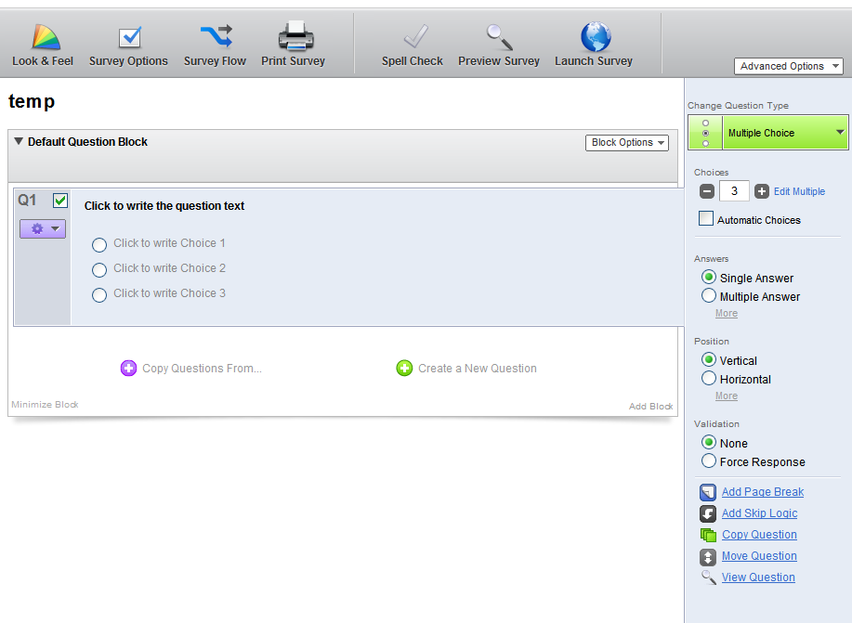

Once you have created a survey with one question, you can now share it with the rest of your group members so that you can collaborate on it. Be careful to have only one person editing it at a time or the software may not capture all of the changes. Clicking on the My Surveys tab brings you back to a screen something like below, where you will see the new survey you have created. Click on Collaborate to allow you to share the survey with your group members.

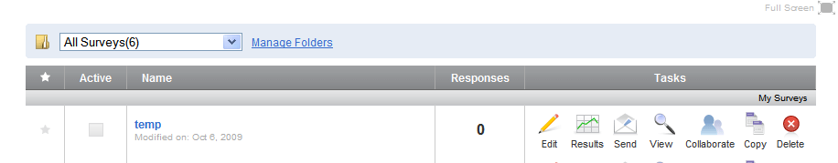

You need to add/share your survey with the rest of your group members so they can both “see” it in their My Surveys area and edit it. After clicking on Collaborate you will simply use the 8.4 email address for each of your other group members. In addition, add your instructor’s email address here as well!

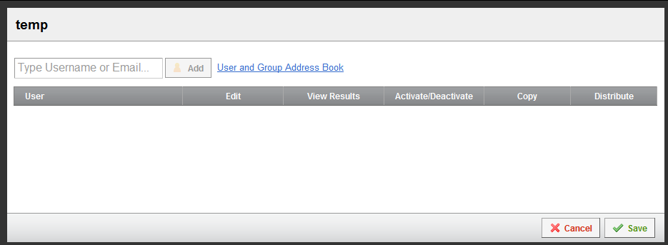

Once you have added your group members and instructor to the survey list, you will need to give them “rights” or “privileges” to edit and manage the survey and results. You can delineate what rights you want to assign, but my recommendation is to check all boxes (edit, view, activate, copy and distribute) for all your group members and your instructor in order to give them the maximum rights.

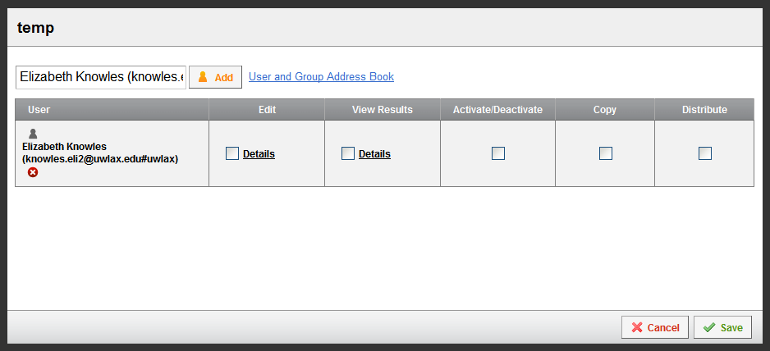

Once they are checked you will need to click save in order to save the changes. Your group members and instructor should now be able to login and see the new survey under their My Surveys tab.

