Tips for Designing your Survey in Qualtrics

A few helpful videos for editing a survey in Qualtrics:

The edit survey tab: http://www.qualtrics.com/tutorials/editsurveytab.html

Different question types: http://www.qualtrics.com/tutorials/questiontypes.html

Multiple Choice Questions: http://www.qualtrics.com/tutorials/multiplechoice.html

Matrix Table: http://www.qualtrics.com/tutorials/matrixtable.html

What if you only want a specific group of respondents to answer a given question or set of questions? How do you designate within Qualtrics which questions should be answered by whom?

You have two options to accomplish this: using skip logic or using blocks with branching. Which one you use depends upon the level of complexity of your individual survey.

If you only need to filter respondents beyond one or a few questions then skip logic is the easiest way to accomplish this. For example suppose that within a banking customer satisfaction survey there are three additional questions just for those customers who have opened an account within the last six months.

Using Skip Logic: http://www.qualtrics.com/tutorials/skiplogic.html

On the other hand, if you have different sets of questions for different groups of respondents based upon a given characteristic then creating blocks and using branching is the cleanest way to accomplish this. Suppose, for example, that within a student survey for the Office of International Education you have a separate set of questions for those students who have studied abroad, those who plan to study abroad, and those who do not intend to study abroad.

Setting up a block: http://www.qualtrics.com/tutorials/blocks.html

Using branching: http://www.qualtrics.com/tutorials/branching.html

To take your survey to ensure there are no problems with it before you launch it:
- click “Preview Survey” on the toolbar near the top of the page

To delete the responses you created by trying your survey:
- select “View Results” tab
- click “Edit Result” on the toolbar
- click on “Delete” button

Tips for Distributing Your Survey in Qualtrics

A simple method which does NOT allow you to personalize the email being sent to the respondent:
- select the “Distribute Survey” tab
- click “Activate your survey to collect responses”
- click “Send Survey” on the toolbar
- paste email addresses into the To: list
- change Subject: (optional but a creative subject line might encourage responses)
- paste introductory message into dialog box
- click “√ Send Now” button

A method for getting a better response rate would entail importing the excel spreadsheet with first and last names along with email addresses into a panel, then distributing the survey to a panel, using the first and last names.

Help videos about panels can be found here: http://www.qualtrics.com/wiki/index.php/Panels
Panel tab is explained here: http://www.qualtrics.com/tutorials/paneltab.html
How to upload an excel file of email addresses to a new panel can be found here: http://www.qualtrics.com/tutorials/panelupload.html
Different actions which can be done on panels is here: http://www.qualtrics.com/tutorials/panelactions.html
Using the Qualtrics software to mail the survey directions can be found here: http://www.qualtrics.com/tutorials/surveymailer.html
Details on creating a personal message, including the informed consent can be found here: http://www.qualtrics.com/tutorials/usingthesurveymailer.html

An informed consent might look something like as follows. You may want to create a panel with just the emails of people in your group and test it on yourselves first.
Dear ${m://FirstName} ${m://LastName},
<clip an informed consent statement here>
The link to the survey is:
${l://SurveyLink?d=Take the Survey}
<clip some other info here, including full contact info>

It is very important to get your responses to these questions, however if you do not wish to respond to this survey, please delete this email
Thanks in advance for responding to the survey,
Taggert J. Brooks, PhD
Associate Professor of Economics
University of Wisconsin-LaCrosse

Reminder and Thank You Emails:
http://www.qualtrics.com/wiki/index.php/Survey_Distribution_Tutorial#Mail_History
If you have used the Qualtrics Mailer to send your survey to a panel, Qualtrics can send reminder emails to those who have not yet finished the survey, and thank you messages to those who have completed the survey.
- Go to the Distribute Survey tab.
- Click on the Mail History button. 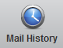
The table displayed shows all mailings scheduled for the selected survey.

- Find the panel, sample, or individual to whom you want to send a reminder/thank you email.
- Click the corresponding gray arrow button in the Actions column. 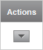

- Select Send Reminder or Thank you in the dropdown list of options
  - 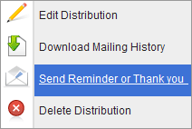

6. In the pop up window select what kind of message you would like to send.
  - 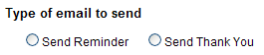
- Schedule the reminder/thank you in the same way that you did the original Invite.
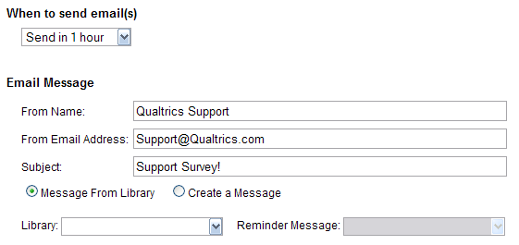
- Specify when to send out the mailing by selecting a specified time frame or by selecting a Custom date and time.
- Make sure the From Name, From Email Address, and the Subject line are correct. These fields are carried over from the invitation and automatically populated, but can be adjusted, if needed.

- Specify if you would like to use a pre-existing message or Create a New Message.
If using a pre-made Reminder message, then select the Library where it is stored and select the message.
If creating a new message, you will need to select which Library to save it to and provide a name for the message. The name is for your own reference purposes and is not seen by the survey taker.

- Click the "Send" button in the bottom right corner of the page when you are finished scheduling the Reminder or Thank You.
Please Note:
- Reminders are sent to those who have not completed the survey. This means those who have not started the survey, as well as those who have started, but not completed the survey.
- Thank You messages are only sent to those who completed the survey, and not to those who did not start at all or started, but did not complete the survey.

